Guide
- Provide up to twenty (20) hours for the review and design of a custom extension to display stock from a location on a separate subsidiary on the Product Details Page of Your SuiteCommerce webstore
SuiteCommerce Standard
SuiteCommerce Implementation: Location stock for other subsidiary in PDP.
POC for Inventory per Location (multi sub support)

Customization
Customization to display stock on item from a location, on a separate subsidiary on the PDP.
Do they want a table to show different stock on different locations?
Same as we did in University of Arizona (Check table)?

Reusable solution from Seba.
https://csnetsuite.custhelp.com/app/answers/answer_view/a_id/1007734/loc/en_US

Stock for different subsidiaries not locations.
https://acct102318.app.netsuite.com/app/common/item/item.nl?id=24518

Item -> Purchasing Inventory -> Locations:
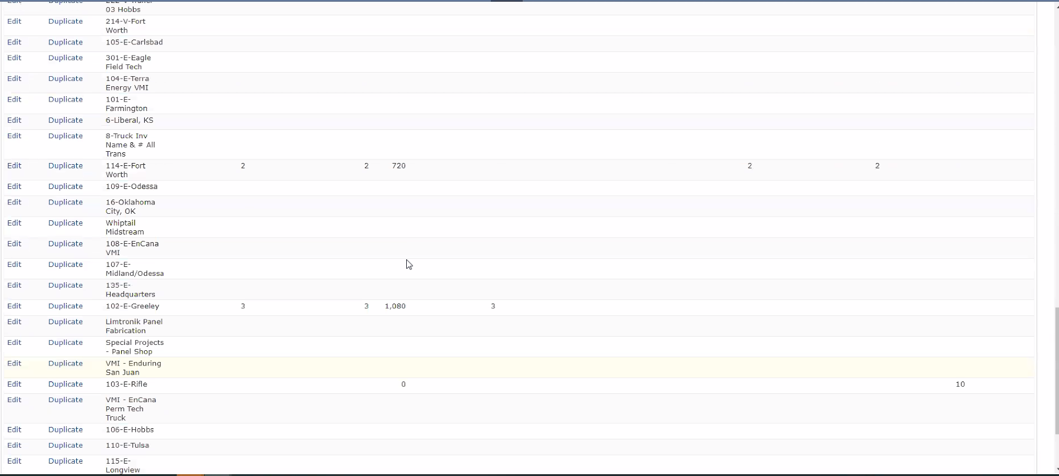
Show ones which have stock. Quantity available.
Solamente mostrar la sumatoria de las quantities available para cada subsidiary, esto viene derecho de item.quantityavailable_detail.locations de la PDP, en la vista

El problema es que no está viniendo para una locación, al parecer es un bug.
20hs.

